Name: ____________________
4-Square
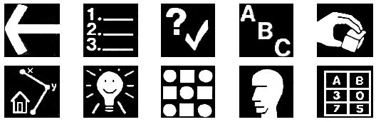
Find Out
Choose a Strategy
Solve It
Look Back

